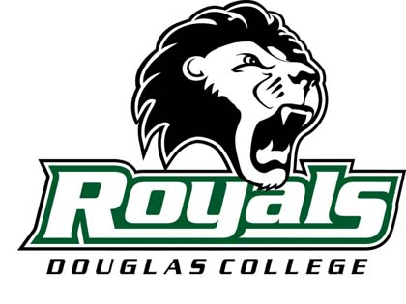

Douglas College Baseball – Recruit Profile Form

If you are interested in being considered for varsity baseball at Douglas College, complete this form and send it via email or mail to Head Coach Cavanagh Whitely. Feel free to add any other information you think is important for us to know about you.

PERSONAL INFORMATION ATHLETIC INFORMATION

Name_____________________________ Height__________ Weight___________
Home Address______________________ Position(s)________________________
Current Team______________________
City______________________________ Coach’s Name_____________________
Province___________________________ Coach’s Phone/email________________
Postal Code________________________ Desired Position at College Level______
Phone Number______________________
Email Address______________________ Athletic Honours Received___________
Date of Birth_______________________ _________________________________
Age____________ Grade_____________ _________________________________

Mother/Father’s Name_______________ ACADEMIC INFORMATION
__________________________________ High School_______________________
How did you hear about the program? Counsellor’s Name_________________
_________________________________ Accumulated G.P.A (%)._____________
_________________________________ Year of High School Graduation_______
Hobbies and Interests________________ Intended post-secondary program at DC
_________________________________ _________________________________
_________________________________ _________________________________

PLEASE RETURN TO:
Cavanagh Whitely Phone: (604) 527-5830

Head Baseball Coach Fax: (604) 527-5032
Douglas College Email: whitelyc@douglas.bc.ca
PO Box 2503
New Westminster, BC


V3L 5B2

